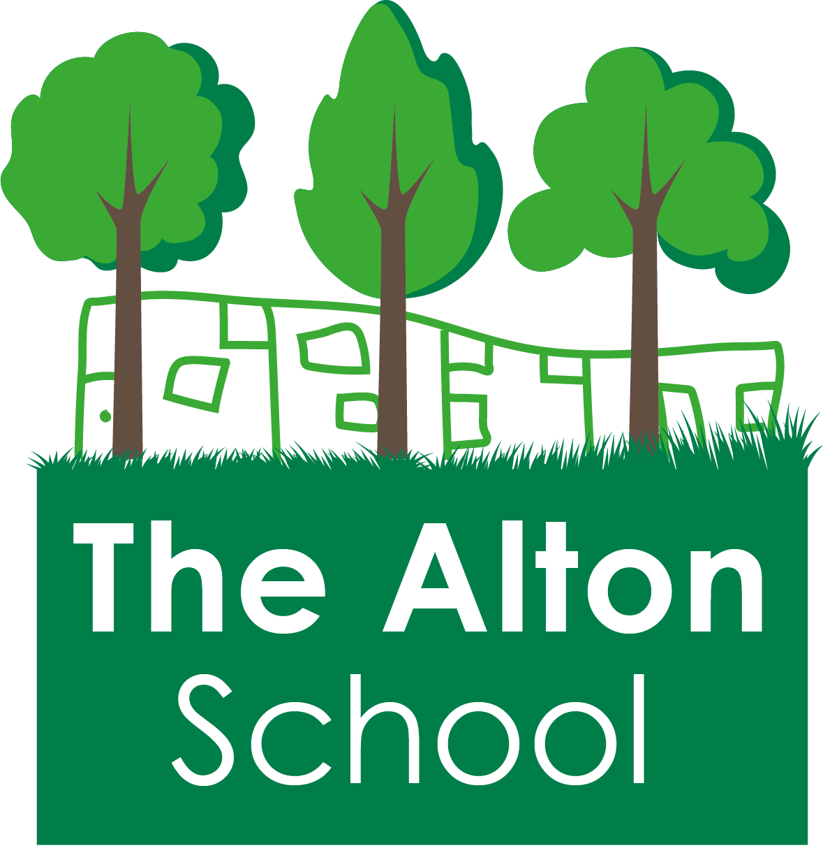

THE ALTON SCHOOL: ADMISSIONS POLICY 2023-24

Admission Number

The admission number for The Alton School for reception year in September 2023 is 30.

Allocation of places: order of priority

Places will first be allocated to children with a Statement of Special Educational Needs or Education Health and Care Plan which names the school. These children will be included in the overall admission number of the school. If fewer applications than the published admission number are received, the school will offer places to all those who have applied. In the event of oversubscription, the school will offer places in the following order of priority:
- A 'looked after child' or a child who was previously looked after (see note 1);

- Children with a professionally supported exceptional medical need or exceptional social need for a place at a particular school, as decided by the trust (see note 2);

- Children with a sibling on the roll of the school on the date of admission living up to a distance of 800 metres from the school. Children with a sibling on the roll of the school on the date of admission living over 800 metres from the school will also receive priority where the family have not moved since the last sibling was offered a place OR the last sibling was admitted prior to 1st September 2016 (see note 3);

- Children of staff at the school (see note 4);

- Other children in order of straight line distance from home to school (see note 5).

If there are more applications than places within any category, applications will be considered in order of straight line distance from home to school (see note 5).

There is no automatic right of transfer from the school nursery to the school reception. Parents must complete the school application form and children will be allocated places in line with the order of priority above.

Notes:

- A looked after child is a child who is (a) in the care of a local authority, or (b) being provided with accommodation by a local authority in the exercise of their social services’ functions (see the definition in section 22(1) of the Children Act 1989).
A previously looked after child is (1) a child who was looked after by a local authority in England but immediately after being looked after became subject to an adoption, child arrangements, or special guardianship order, or (2) a child who appears to the admission authority to have been in state care outside of England and ceased to be in state care as a result of being adopted.
An adopted child is defined by section 46 of the Adoption and Children Act 2002 or section 12 of the Adoption Act 1976.
A residence order is defined by section 8 of the Children Act 1989.
A child arrangement order is defined by section 8 of the Children Act 1989 as amended by section 14 of the Children and Families Act 2014.
A special guardianship order is defined by section 14A of the Children Act 1989.

- Applications made on exceptional medical grounds must be supported by a current letter from a specialist health professional. Applications made on exceptional social grounds must be supported by a current letter from a social worker or other care professional working with the family. The letters must give reasons why the child's condition or circumstances make it necessary for the child to attend the school applied for, and the difficulties that would be caused if the child had to attend an alternative school. If this information is not provided by the application closing date, the application will not be considered under this criterion. The school may request professional advice before a decision is reached.

- A sibling is a full brother or sister, a step/half brother or sister living at the same address, a child who is living as part of the family by reason of a court order, or a child who has been placed with foster carers as a result of being looked after by a local authority.

- The member of staff must have been employed at the school for at two or more years at the time at which the application to the school is made or be a member of staff who was recruited to fill a vacant post for which there was a demonstrable skill shortage.

- The straight-line measurement used to prioritise applicants for admission to schools in Wandsworth commences in all cases at the location of the property determined by the National Land Planning Gazetteer and terminates at the central point of the school site as determined by Wandsworth Council’s Geographical Information System. Measurements by alternative systems and/or to other points will not be taken into account in any circumstances. Where applicants have identical distance measurements, priority amongst them will be determined at random. The permanent address of the parent/guardian with whom the child is living on the closing date for applications will be used for this purpose. A parent/carer may be asked to provide evidence to verify an address. The council should be informed of any change of address as soon as it becomes effective.
Where a child lives with parents with shared custody/responsibility, the address where the child spends the majority of the week should be used by parents for the school application. If there is a genuine 50/50 shared arrangement in place, the address where the child lives is determined using a joint declaration from the parents stating the pattern of residence. In cases where an agreement cannot be reached between the parents and Child Benefit is claimed, the address that is registered for this claim will be used. Additional proof may be requested, e.g. court order or a solicitor’s letter to confirm the arrangements.

ADDITIONAL INFORMATION

Method of Application for Reception
Admissions for our school are coordinated via the London Borough of Wandsworth. Parents/carers must apply through the Common Application Form.
If you live in Wandsworth borough, please visit www.wandsworth.gov.uk/admissions to access more information about the admissions process, complete the application online or download a copy to complete on paper.
If you live in another borough, you must apply through your local authority.

Waiting List
Unsuccessful applicants (including any applications received after the closing date) will be included on the school’s waiting list ranked in order of priority under the published oversubscription criteria, without regard to the date that the application was received. Please note a child’s position on the waiting list can go down as well as up. For example, if a new application is received or if a child on the list moves nearer to the school, the waiting list may need to be revised. The offer of a place does not depend on the length of time your child’s name has been on the waiting list.

Appeals
Parents/carers whose child has been refused a place at the school have a legal right to appeal against this decision to an Independent Appeal Panel. Our school has appointed the Wandsworth Appeals Service, which is responsible for arranging appeal panels on our behalf. Please visit www.wandsworth.gov.uk/admissions for information about the appeals process or contact educationappeals@wandsworth.gov.uk. The school will publish an appeals timetable on its website showing the relevant deadlines.

In Year Admissions
For in year admissions (when you apply outside the normal admissions round), parents/carers must apply to the school on the Wandsworth In Year Common Application Form. Applications will be considered in accordance with the above order of priority.

Deferred Entry and Delayed Admission to Reception
The law states that children must attend school full-time from the beginning of the term after their fifth birthday. Children will normally start reception in the September following their fourth birthday. However parents/carers may defer their child’s entry to later in the school year, or delay admission to reception to the following year. For more information on this, please read the admissions information on the Wandsworth Borough Council website.
If you wish to defer entry until later in the school year, you must still apply at the normal time through the normal application process. You should then contact the school in writing after you have been offered a place.
If you wish to delay admission to reception until the following year, you must still apply at the normal time through the normal application process, including a written request with your application. We would encourage you to contact the school first so that we can discuss how your child's needs could be met within their chronological age group, and the impact of being educated with children of a different age group, before you make your decision.

