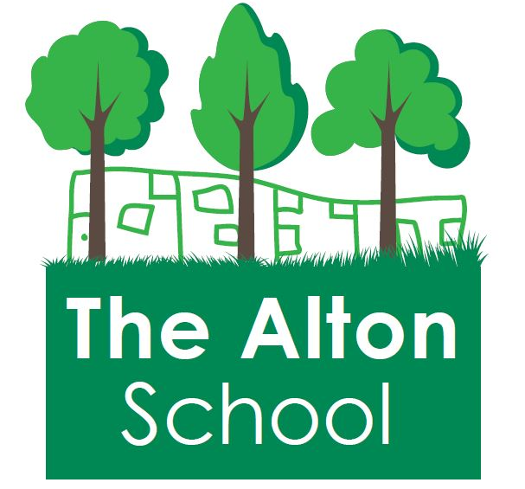
The Alton School Newsletter

Dear Parents, Carers, Friends and Colleagues,
Rights Respecting School
This week we focused on the Article 24: You have the right to safe water to drink. Our Excellent Learner quality was: Excellent Learners like a challenge. Please support us by using the language of Excellent Learners as well as rights and responsibilities with your children, asking them what they have been learning about.

This Week at The Alton
On Tuesday Years 1 and 2 visited the science museum to see George Stephenson’s Rocket locomotive and learn about famous scientists. Everyone really enjoyed the day. Thank you to the parents who came and helped out!
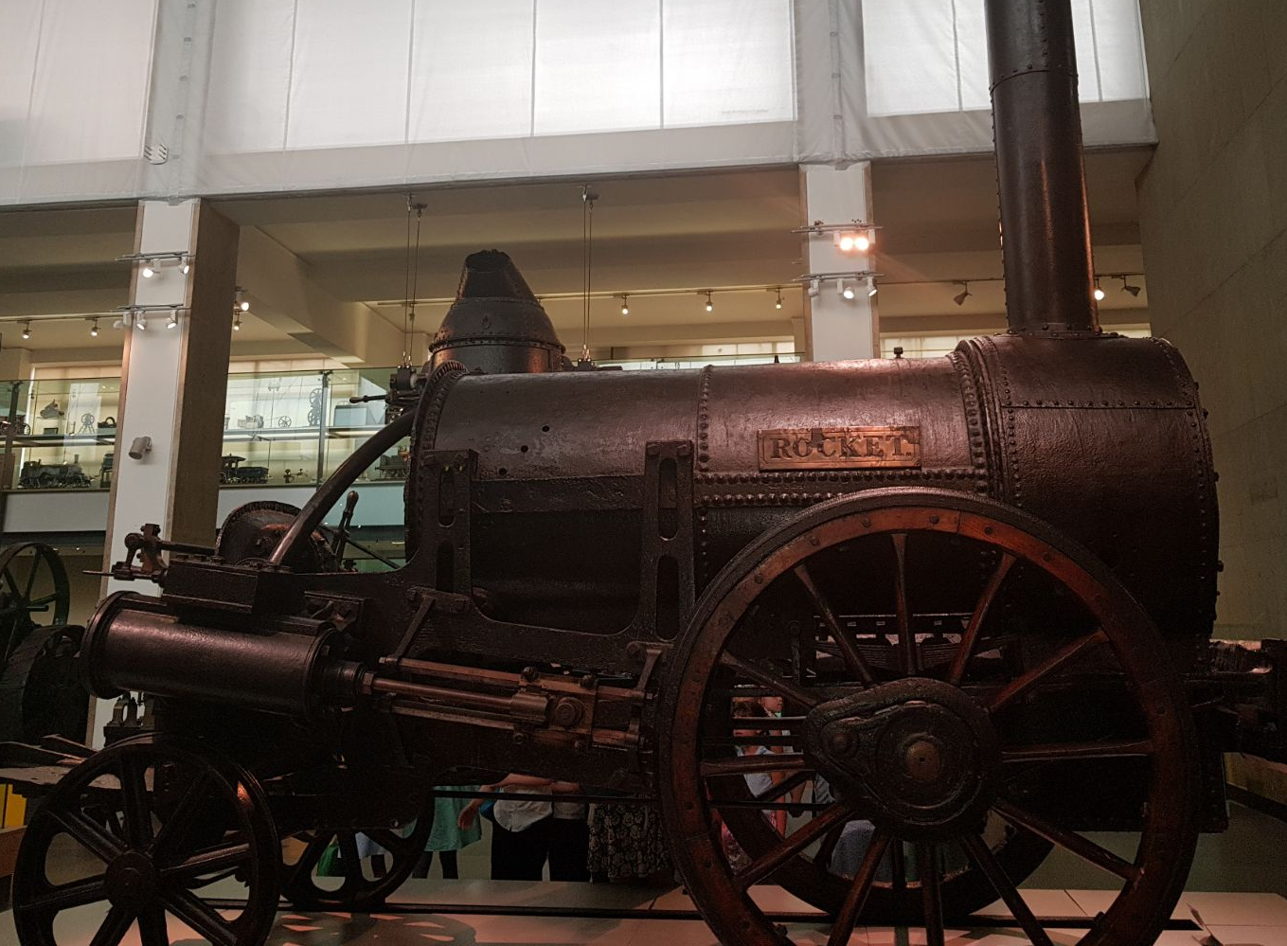

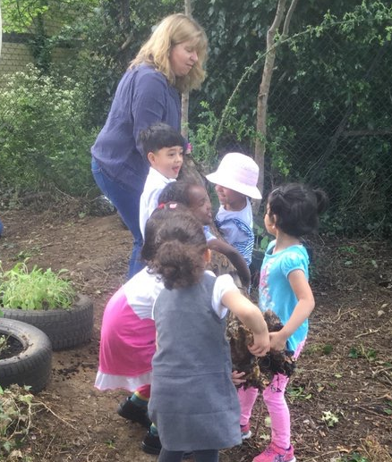
On Thursday, the Early Years spent the day gardening and reorganising the outdoor garden areas. Lots of parents gave up their time to come and help, and the children were
busy moving logs and being
careful of the wildlife. Thank you
to all the parents, children and
staff for their time and effort in
making this possible.
11th May
2018

Year 3 - Heritage award winners!
On Thursday evening, Year 3 and their parents were invited to attend the award ceremony to collect their prizes for winning the Key Stage 2 entry of the Wandsworth Heritage award for schools. Every child received a medal and certificate and the school has been given a plaque commemorating their success as well as £1000 prize money! It was an excellent event, and the children received their awards from the Deputy-Mayor of Wandsworth, Ian Lewer. Lots of other schools were there to receive their prizes too and the children, parents and staff who attended all had a brilliant time. As a school we are so proud of the children for all their hard work. We would also like to thank Mrs. Jones and Mrs. Downey for organising this for them.
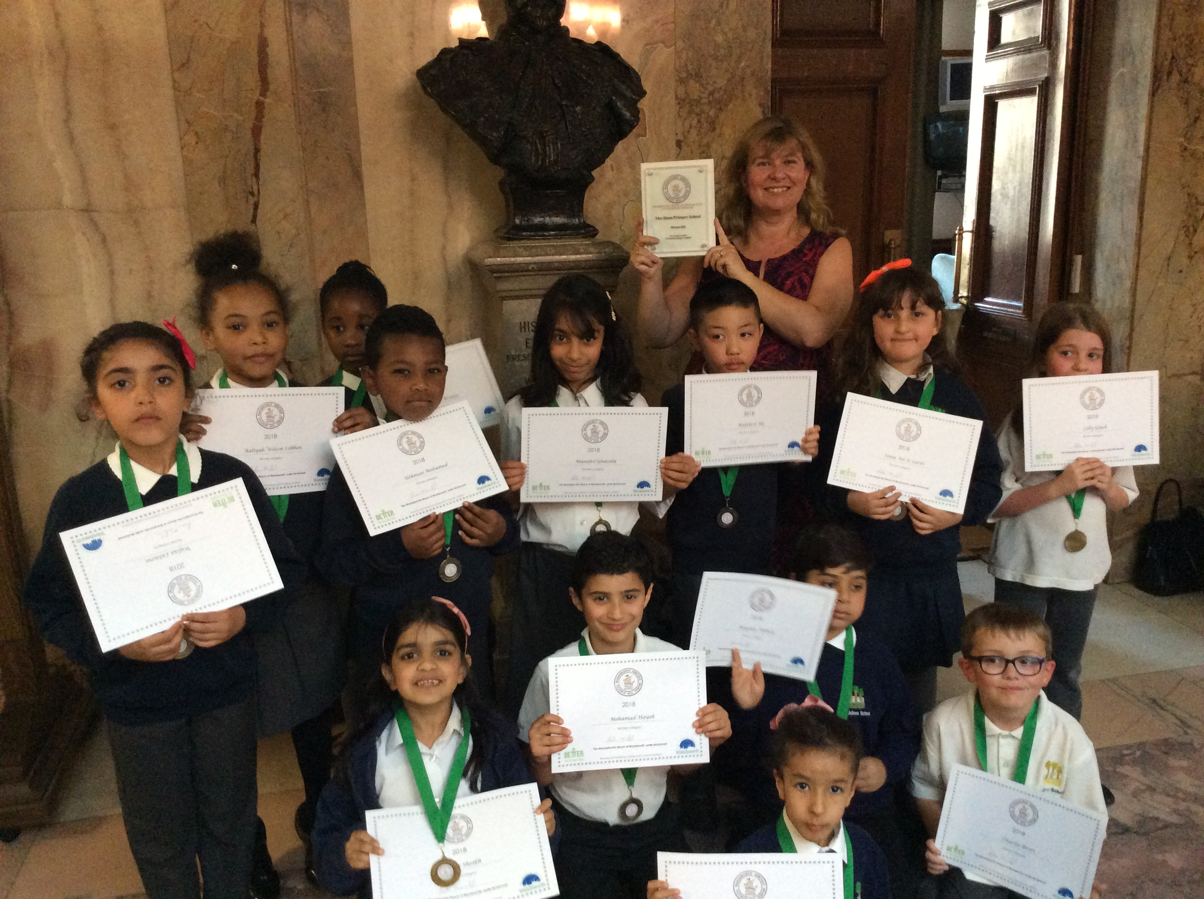

8th May Achievement Assembly:
During our Achievement Assemblies, the following students were awarded their certificates:

Big Writers: Aiza(YN); Rizwan(YR); Christene(Y3); Ramzy(Y4); Abdelhadi(Y5) Ibrahim(Y6) & Ben(RB);

Excellent Learners: Yahia(YN); Omar(YR); Aaliyah(Y3); Adam(Y4); Dajharn(Y5) Rahma(Y6) & Ryan(RB)

Reader of the Week: Ibrahim Y6
Attendance: Reception 3 and RB 3100%

Messages from the office:
You may receive a letter today from the office regarding Ramadan and Eid. Please read this carefully and return the slip to the office as soon as possible.

The summer fair is fast approaching. It is on Saturday 30th June. If you are interested in helping out please see Abi Cutmore for more information. More details to follow shortly.

Next week at The Alton:

Year 6 have their SATs next week, please make sure the children are well rested. They have worked incredibly hard and we are very proud of them. On Friday, Year 5 are visiting the Science museum.

With best wishes,
Ruth Hudson
Headteacher

Dates for your diary
14th May Y6 Statutory assessment week (SATs)
18th May Year 5 trip to the Science Museum
18th May Year 1 Class assembly 3pm
23rd May Nursery visit to Deen City Farm
25th May EYFS assembly 3pm
25th May 3.30pm School closes for half term
28th May to 4th June School is closed to pupils
4th June School closed to pupils but open for staff training and buying uniform. (INSET)
4th -15th June Open lessons
5th June 8am Breakfast club. 8.45am class doors open.
11th June Phonics screening week for Year 1
12th June Recycling workshops in school
12th June Spelling Bee Y5 and Y6 group
18th June Book Fair arrives
19th June Sports day
25th June MUNGA for Year 5 group
26th June Road safety workshop for Y6
30th June Summer Fair
20th July School closes for the summer holidays

