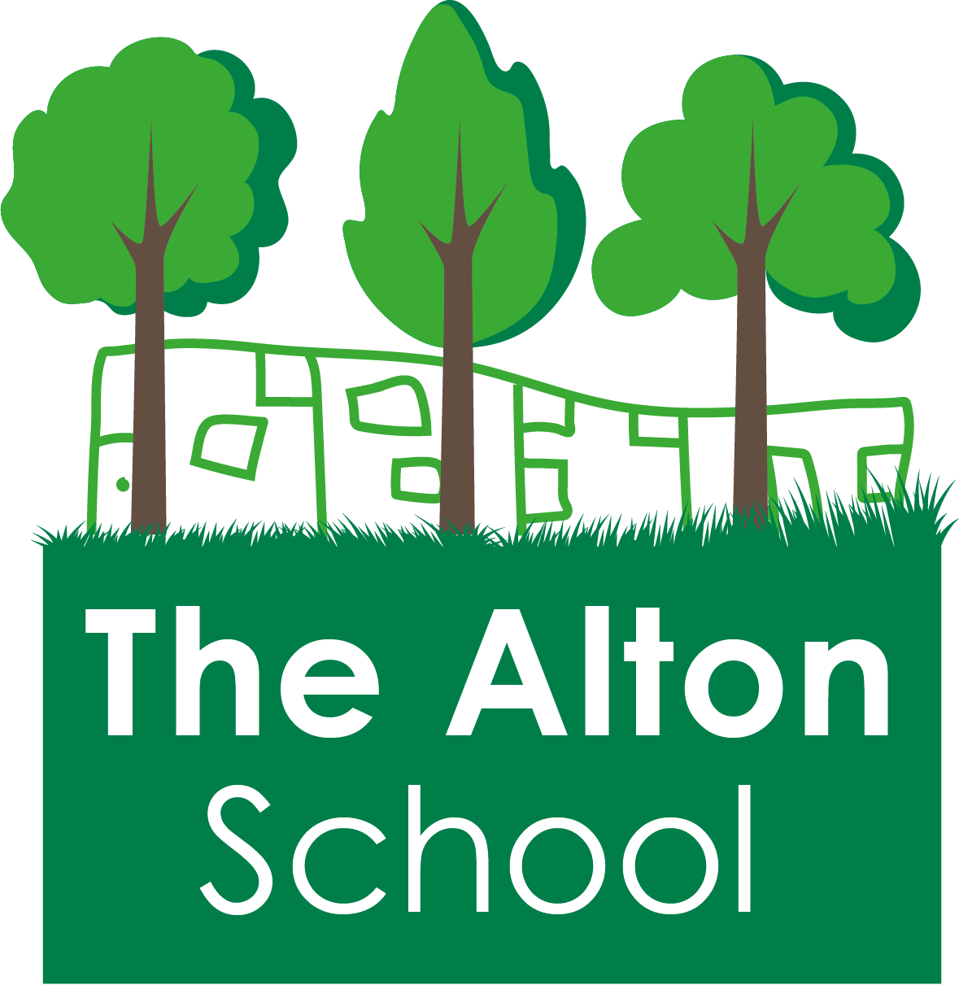
The Alton School Newsletter

Dear Parents, Carers, Friends and Colleagues,
Rights Respecting School
Next week we are focusing on Article 31: All children have all of the right to play and rest.The students will learn that with this right comes the responsibility to respect others rights as well.
Our Excellent Learner quality is: Want to learn more.
Please support us by using the language of Excellent Learners as well as rights and responsibilities with your children, asking them what they have been learning about.
Year 6 Wandsworth Tests
All the pupils in Year 6 will be sitting these tests on Thursday 20th September, during their normal school day. This test has been designed to provide Wandsworth secondary schools with information about all Year 6 pupils before they offer places for next year.
If you have questions about these tests please speak to Mr. Sarker during the Year 6 Parent Meeting on Tuesday 18th at 3pm.
Secondary School for Year 6
Applications for secondary schools are open now until 31st 0ctober 2018. Your children will be bringing home some information for you to help choose a school. Please make sure you let Mrs. Gibbs, in the school office, know in advance if you will be attending any Open Days.

14th September 2018

School start and end arrangements
Thank you for supporting us with the new timings of the school day, it has been a great success. In order to cause the least disruption to the office staff, the pedestrian gate will open at 8.20am and 3.05pm for you to come on to the school site. Please try to keep to these times whenever possible so the buzzer is not constantly sounding in the office.
Year 6 is always an important year, but this year the children are not always in at our early time of 8.30am. It would be great to see this improve.
Staff vacancies
We are currently advertising for a Learning Mentor as well as a Learning Support Assistant to join our very successful staff team. If you would like more information, please come and speak to Mrs. Matthews in the school office. It might be for you or for someone you know…
Parent and Carer suggestions
We have a new area in the front of the school office for you to leave a suggestion or question. You can also call us on 020 8876 8482, email admin@thealton.wandsworth.sch.uk or download a suggestion form from our website. These will also be addressed in our newsletters if it is helpful to many parents.

School uniform
Thank you to all of you who have ensured that your children come to school in full uniform. The weather is now beginning to be changeable as we move into the autumn so it is important that your children come to school with their jumpers and coats so they can go outside and play. Please remember that we ask you not to let your children wear hoodies to school instead of coats and jackets.
Clubs
Today is the deadline for your applications for the after school clubs so they can begin next week and finish in the week beginning 17th December. Please make sure that Mrs. Gibbs has your completed form and fees due.
PGL
The meeting for the parents of Year 5 pupils was held yesterday to discuss the PGL trip to the Isle of Wight. If you were unable to attend, or have some more questions, please speak to Mrs. Harwood or Mrs Matthews.
This week at The Alton
On Monday, we held our first Achievement Assembly of this school year. Read on to find out who was a successful learner this week.
On Tuesday, all the staff had more training in our new mathematics programme, Maths – No Problem! Ask your children how this new way of doing maths is different to last year.
Also, Year 5 had their Parent Class Meeting.
On Wednesday, Year 1 had their Parent Class Meeting.
On Thursday we held our Excellent Learners and Rights Respecting Assembly. Please ask your child what happened in this assembly.
Also, Year 4 had their Parent Class Meeting and Year 5 had their PGL Meeting.
Today, all the Year 6 candidates for our Pupil Leadership Team spoke about why they should be elected to these important posts. Thank you to all of you who came and took part in this election. Please look out next week to see which candidates were successfully elected as Head Boy, Head Girl, Deputy Head Boy, Deputy Head Girl, Assistant Head Boy and Assistant Head Girl.
Next week at The Alton
Clubs will begin next week, please make sure you know which club your child is in, and what day it is on. Children must be collected on time at the end of their club.
We will continue with our Parent Class Meetings at 3pm next week. On Monday it is Year 3. On Tuesday it is Year 6. On Wednesday it is Year 2. On Thursday it is Reception. On Friday it is Nursery.
On Thursday, Year 6 pupils will all be taking their Wandsworth Tests. Please make sure they had a good night’s sleep, a good breakfast and are here at 8.30am ready to start.
On Friday at 2.50pm it will be the Year 5 Class Assembly. Everyone is invited to come and find out what they have been learning. I look forward to hearing their ideas and seeing many of you there.
With best wishes,

Ruth Hudson
Headteacher

Dates for your diary
17th Sept 3pm Year 3 Parent Meeting
18th Sept 3pm Year 6 Parent Meeting
19th Sept 3pm Year 2 Parent Meeting
20th Sept Year 6 Tests
3pm Reception Parent Meeting
21st Sept 2.50pm Y5 Class Assembly
3pm Nursery Parent Meeting
28th Sept 2.50pm Y6 Class Assembly
5th Oct 2.50pm Y4 Class Assembly
12th Oct 2.50pm Y3 Class Assembly
19th 0ct 3.15pm School closes for half term.
22nd to 26th October school is closed to pupils – half term holiday
29th Oct 7.45am Breakfast club. 8.30am classes open.
2nd Nov 2.50pm Y2 Assembly
9th Nov 2.50pm Y1 Assembly
16th Nov Children In Need
23rd Nov 2.50pm EYrs Assembly
18th Dec 2pm School Christmas Play
21th Dec 3.15pm School closes for Christmas
24th December 2018 to 7th January 2019 School is closed to pupils
7th Jan School closed to pupils but open for staff training and buying uniform. (INSET)
8th Jan 7.45am Breakfast club. 8.30am classes open.
18th Jan 2.50pm Y6 Class Assembly
25th Jan 2.50pm Y5 Class Assembly
1st Feb 2.50pm Y4 Class Assembly
8th Feb 2.50pm Y3 Class Assembly
15th Feb 3.15pm School closes for half term
18th to 22nd February School closed to pupils – half term holiday
25th Feb 7.45am Breakfast club. 8.30am classes open.
8th Mar 2.50pm Y2 Class Assembly
15th Mar 2.50pm Y1 Class Assembly
22nd Mar 2.50pm EYrs Class Assembly
5th April 3.15pm School closes for Easter
8th April to 22nd April School is closed to pupils – Easter Holidays
23rd Apr 7.45am Breakfast club. 8.30am classes open.
6th May School closed for Bank Holiday
27th May 3.15pm School closes for half term
27th May to 31st May School is closed to pupils – half term holiday
3rd June School closed to pupils but open for staff training and buying uniform. (INSET)
4th June 7.45am Breakfast club. 8.30am classes open.

