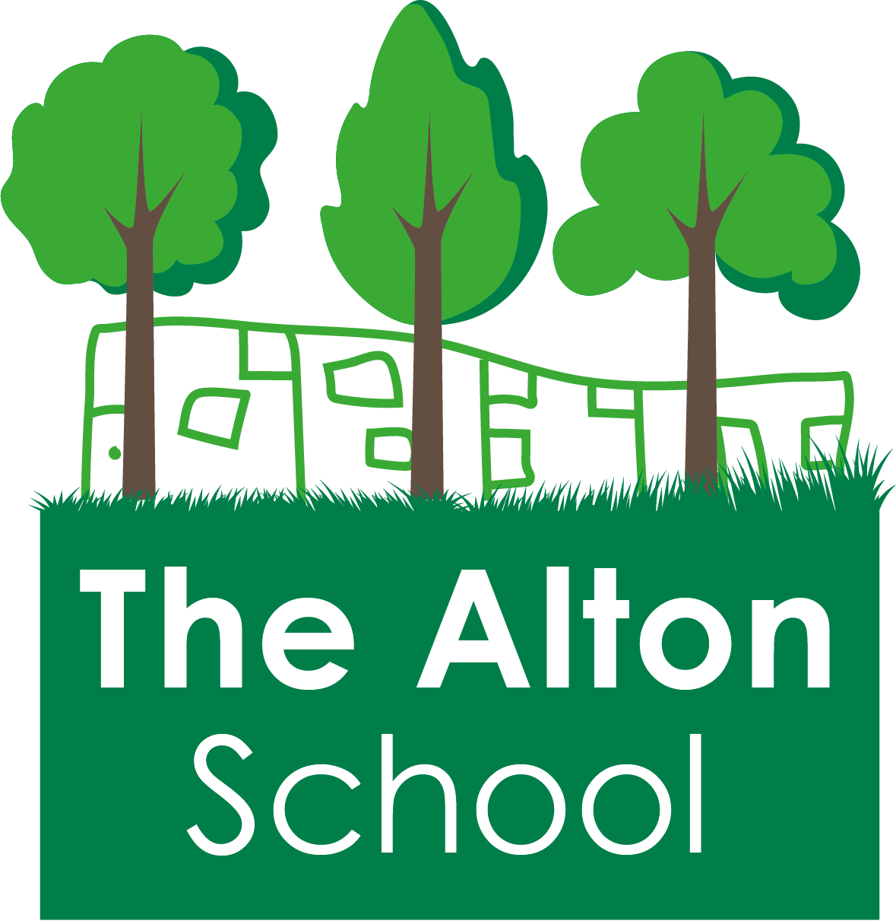
The Alton School Newsletter

Dear Parents, Carers, Friends and Colleagues,
End of term
Today is the last day of term.
I hope that you all have a peaceful and enjoyable holiday.
School is open for children on Tuesday 7th January 2020. Breakfast Club begins at 7.45am and the classroom doors open at 8.30am.
Winter Fair
Thank you to everyone who came and helped at the Winter Fair, who donated items for us to sell or who came and spent their money. We are grateful for all the support that you give us. We raised £880 which includes a donation of £65 from a group of mothers.
Christmas Jumper Day
Thank you to everyone who joined in with raising money for the Save the Children charity by wearing a festive jumper instead of their school jumper last Friday. You raised £149 and should be proud of this!
Christmas Play
The Christmas play was wonderful as always, and I was overwhelmed by the number of families who came to support their children, thank you. Your children and the staff worked very hard to put on performance for you to enjoy and it was spectacular.

19th December 2019

End of Term Achievement Assembly
Today was our End of Term Achievement Assembly for Autumn 2019. Thank you to everyone who came to help us celebrate progress, effort and hard work that all the children have achieved.
100% Attendance Assembly and Tea Party
We shall hold our 100% Attendance Assembly for the second half of the Autumn Term and for the whole Autumn Term on Thursday 9th January at 2.30pm.
The Tea Party for the children and their parents will be on Friday 10th January at 2.45pm.
Parent suggestion or question
If you would like to make a suggestion please email:
admin@thealton.wandsworth.sch.uk
Or you could write to me or hand in your suggestion to the school office. I am sure your suggestions and questions will be useful to other parents as well.

With best wishes,
Ruth Hudson
Headteacher

Dates for your diary

20th December 2019 to 7th January 2020 School is closed to pupils
6th Jan School closed to pupils but open for staff training
7th Jan 7.45am Breakfast club. 8.30am classes open.
9th Jan 2.30pm 100% Attendance Assembly
10th Jan 2.45pm 100% Attendance Tea Party
17th Jan 2.50pm Y6 Assembly
24th Jan 2.50pm Y5 Assembly
31st Jan 2.50pm Y4 Assembly
14th Feb 2.50pm Y3 Assembly
14th Feb 3.15pm School closes for half term

17th to 21st February School closed to pupils – half term holiday

24th Feb 7.45am Breakfast club. 8.30am classes open.
28th Feb 2.50pm Y2 Assembly

5th Mar World Book Day
6th Mar 2.50pm Y1 Assembly
13th Mar 2.50pm Nursery & Reception Assembly
3rd April 3.15pm School closes for Easter

6th April to 21st April School is closed to pupils – Easter Holidays
20th Apr School closed to pupils but open for staff training
21st Apr 7.45am Breakfast club. 8.30am classes open.
8th May School closed for Bank Holiday to commemorate Victory in Europe
22nd May 3.15pm School closes for half term
25th May to 29th May School is closed to pupils – half term holiday

17th July 2020 Last day of school before school closes for the summer

