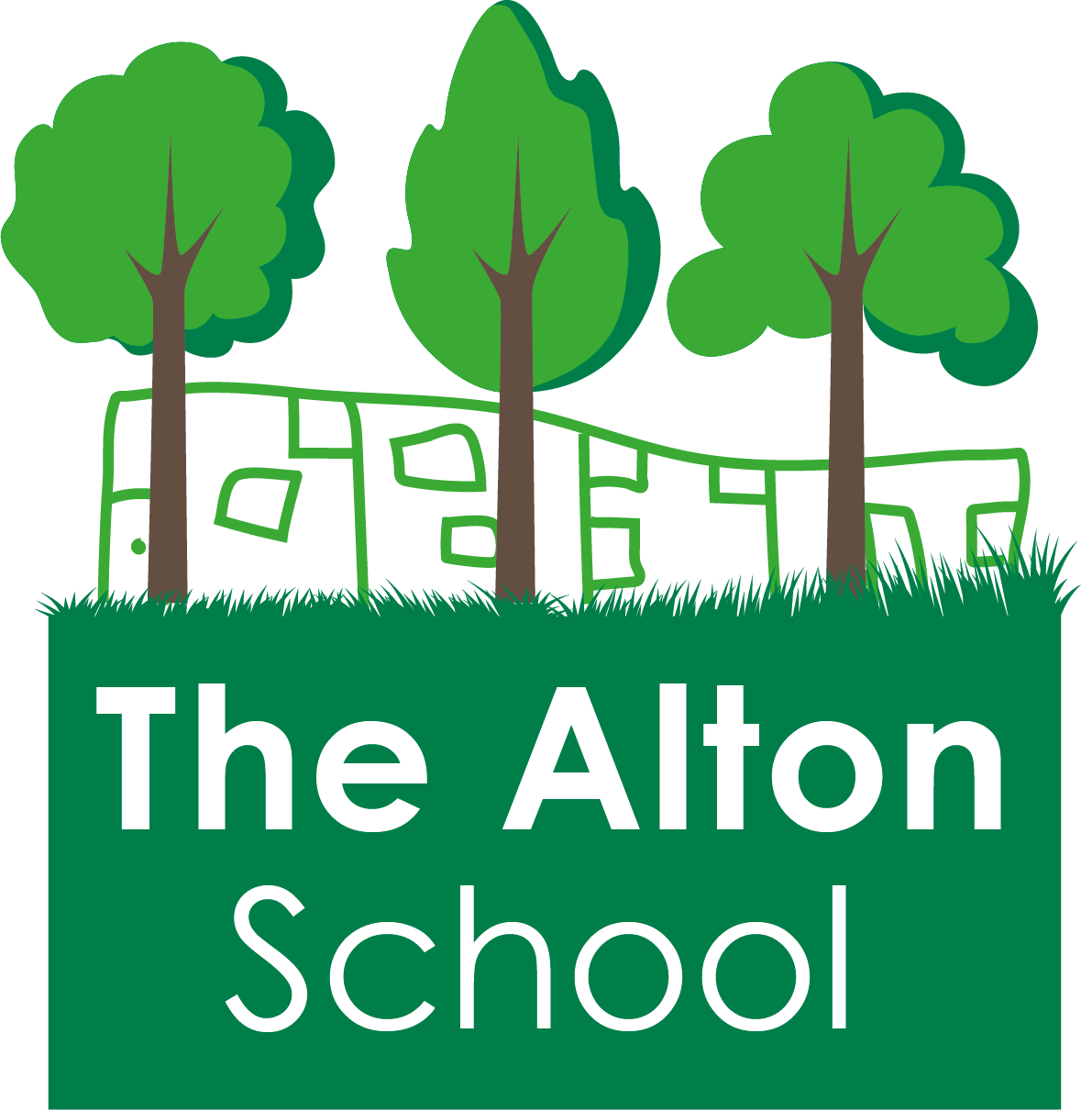
The Alton School Newsletter

Dear Parents, Carers, Friends and Colleagues,
Rights Respecting School
This week we focused on Article 7: You have the right to a nationality. The pupils learnt that with this right comes the responsibility to respect adults who are protecting them and to respect other people’s right to have these things.
Next week we shall focus on Article 8: You have the right to an identity.
Our Excellent Learner quality was: Ask questions.
Next week our Excellent Learner quality will be: Are not afraid to make mistakes.
Please support us by using the language of Excellent Learners as well as rights and responsibilities with your children, asking them what they have been learning about.
Online Safety
This week was Online Safety Week. Melanie, our Place2Be project manager ran a coffee morning yesterday where many of you expressed your concerns about your children’s use of the internet and how to keep them safe. A key thing is for you to know what your children are doing online, so please talk to them and check their browsing history regularly. It is also important for your children to use their tablets or telephones in family spaces, where you can check on what they are looking at.

Friday 9th February 2019

A very useful website is nspcc.org.uk which have a section called Online Safety. This is full of tips and suggestions about the use of social networks, apps, games and more. There is also a helpline to call to get advice and talk to experts: 0808 800 5002.
We are always happy to help and offer you support too. Please come and speak to me, Mrs. Thomson or Ms. Morris at any time.
Reminders from the Office
Please keep Mrs. Gibbs upto date with all of your contact details when you change your telephone or email addresses. We use these to share important information as well as in emergency situations.
Congratulations!
I am very pleased and proud to let you all know that Mrs. Harwood and Ms. Wilding are our new Assistant Headteachers. I know they will do a great job and that you will appreciate the work they do for your children. Please do give them your congratulations.
Volunteers
We are very lucky to have some parents who support us by volunteering in school and we thank them very much. If you would like to offer your support too, please come and speak to Mrs. Gibbs in the office, or let Mrs. Thomson or me know. We are a very welcoming place to be in!

Place to Play!
Every Friday, from 3.15 to 5pm, you are all invited to stay in school and play with your children with a trained play specialist. This is very popular and a great chance to have some quality time with your child. Please come along and see how it works. Sessions are free and great fun!
This week at The Alton
On Monday, the Fire Brigade came to school and all the pupils in Nursery and Reception were allowed to climb inside and look around. They had great fun turning on the lights and sirens!
On Thursday, Place2Be ran a coffee morning which was very popular. Everyone is invited to come to the next one and I will let you know the date as soon as possible.
Today, our assembly was about Online Safety. Please talk to your children about this and ask them about their games and apps. The internet is a wonderful tool and as with all things, our children need to be taught how to use resources properly.
Next Week at The Alton
On Monday, Y5 are going on a trip to the British Museum as part of their work on the Vikings.
Also on Monday, the pupils in Reception and Y6 are having their heights and weights recorded.
Friday is the last day of this half term. We finish as normal at 3.15pm. School re-opens on Monday 25th February at 7.45am for Breakfast Club and 8.30am for everyone else.
Parent and Carer suggestions
We have an area in the front of the school office for you to leave a suggestion or question. You can call us on 020 8876 8482,

email admin@thealton.wandsworth.sch.uk or download a suggestion form from our website. These will also be addressed in our newsletters if it is helpful to many parents.
A parent asked about whether we could let you know what the theme will be for World Book Day on 7th March 2019.
This year we are not having a whole school theme as each class are going to come dressed as a character in the book they are studying. These are the books:
Nursery: Rosie’s Walk by Pat Hutchins
Reception: The Naughty Bus by Jan Oke
Y1: The Piano Girl by Ann Ingalls
Y2: The Bear and the Piano by David Litchfield
Y3: The Iron Man by Ted Hughes
RB1: Rosie’s Walk by Pat Hutchins
RB2: Greek Mythology, a collection
RB3: The Sound Collector by Roger McGough
Y4: The Stone Mouse by Jenny Nimmo
Y5: The Lady of Shalott by Alfred Tennyson
Y6: Macbeth by William Shakespeare
Please talk to your child’s teacher if you need any costume ideas.

With best wishes,
Ruth Hudson
Headteacher

Dates for your diary
11th Feb Y5 trip to the British Museum
Reception & Y6 heights and weights
15th Feb 3.15pm School closes for half term
18th to 22nd February School closed to pupils – half term holiday
25th Feb 7.45am Breakfast club. 8.30am classes open.
26th Feb Parents’ Evening
28th Feb 2.30pm 100% Attendance Assembly
4th Mar Open Lessons week
5th Mar 9.30am Early Years Open Morning
6th Mar Y4 trip to Bockett’s Farm
7th Mar World Book Day
8th Mar 2.50pm Y2 Class Assembly
21st Mar Y4 & Y5 trip to Battersea Power Station
22nd Mar 2.50pm Y1 Class Assembly
27th Mar Book Fair for one week
29th Mar 2.50pm EYrs Class Assembly
1st April Y5 PGL trip to the Isle of Wight
5th April 3.15pm School closes for Easter
Y5 return from the Isle of Wight
8th April to 22nd April School is closed to pupils – Easter Holidays

23rd Apr 7.45am Breakfast club. 8.30am classes open.
25th Apr 2.30pm 100% Attendance Assembly
3rd May 2.50pm Y5 Class Assembly
6th May School closed for Bank Holiday
7th May 9.30am Early Years Open Morning
10th May 2.50pm Y4 Class Assembly
17th May 2.50pm Y3 Class Assembly
24th May 3.15pm School closes for half term
27th May to 31st May School is closed to pupils – half term holiday
3rd June School closed to pupils but open for staff training and buying uniform. (INSET)
4th June 7.45am Breakfast club. 8.30am classes open.
9.30am Early Years Open Morning
6th June 2.30pm 100% Attendance Assembly
14th June 2.50pm Y2 Class Assembly
21st June 2.50pm Y1 Class Assembly
28th June 2.50pm EYrs Class Assembly
2nd July 9.30am Early Years Open Morning
18th July 2.30pm 100% Attendance Assembly
19th July 12pm School closes for the summer.

