Danebury Avenue, Roehampton, London SW15 4PD
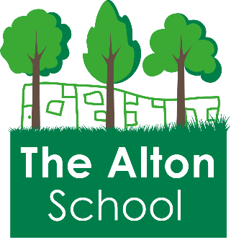
Tel: 020 8876 8482
Web: www.altonschool.org.uk
Email: admin@thealton.wandsworth.sch.uk

Headteacher: Ruth Hudson

Deputy Headteacher: Linsay Thomson

Class Teacher
Full Time, Permanent.
Inner London Main Teachers Pay Scale
NQT considered
Start Date September 2021
Closing Date 19th April 2021
An exceptional opportunity has arisen for you to join the lovely team of staff at The Alton School.
Our vision is to give every child in our community an exceptional education - our school is an exciting one to work in and we have a team of committed staff and governors who work exceptionally hard to give the children in our community the very best. Staff are exceptionally well supported and developed as outstanding practitioners and leaders partly due to being part of a small local Trust with all the benefits that that brings. We have a strong inclusive and supportive ethos, experienced teaching assistants in each class, a well-resourced curriculum and fabulous children. We serve a diverse multi-cultural community and celebrate the richness that this brings to school life. If you want to be part of something truly special, please contact Helen Gibbs on 020 8876 8482 to have an informal chat with the Headteacher, Ruth Hudson.

We offer:

- The opportunity to work with the most wonderful students anywhere in the country
- A warm, mutually supportive and caring ethos with enthusiastic and skilled staff who are highly aspirational and committed to pupil welfare, progress and life-chances
- A highly experienced and effective leadership team within both the school and Trust who can support excellent opportunities for CPD including the opportunity to influence and lead education developments both locally and nationally through cross school partnership.
- A clear vision for the future
- A positive and enthusiastic, well-resourced and attractive working environment with extensive grounds
- A commitment to working with and within our local community
- A happy school - where children smile, they are eager to learn and where standards are high.
- Support and guidance from your phase leader during their weekly leadership time
- High quality administrative support
- A successful NQT Support Programme within the Trust.
- Onsite Parking

We are looking for someone who can demonstrate:

- Excellent classroom practice that demonstrates creativity and caring with the ability to make learning fun
- High expectations and a commitment to providing the best possible education for all pupils
- The ability to be flexible, dynamic, enjoy a challenge, be good at thinking on your feet and well organised
- Be driven and ambitious for the learners, the school and on a personal level
- Have experience or a keen interest in supporting SEND learners
- Have the unswerving desire to support the values and aims of The Alton School and the needs of its pupils and staff
- The ability to work as part of a team and to inspire, support and lead others
- Experience of working in a multi-cultural environment
- A willingness to run an after school club would be expected
Please telephone or email the office to arrange for further details.
Completed applications should be returned to the school by email to admin@thealton.wandsworth.sch.uk
Tel: 020 8876 8482
We review applications on a rolling basis and early applications are recommended.
We are committed to safeguarding and promoting the welfare of children, young people and vulnerable adults and expect all staff and volunteers to share this commitment.
This post is subject to an enhanced DBS check.
Applicants regardless of race, colour, nationality, ethnic origin, sex, marital status, disability or age will be welcomed. All applicants are considered on the basis of their merits and abilities for the job. Safeguarding procedures to promote the welfare of all children are in place. Any offer of employment will be subject to a satisfactory check supplied by the Disclosure and Barring Service.

