Maths  This half term we have been focussing on our times tables. Write out the times table that you have been working on in class and see if you can spot any patterns. Are the patterns the same with a different table? | DT  This half term we have read lots of different books. Can you create a model of one of the characters from your favourite book? | Science/Art:  Visit a park or open space and draw evidence/ create a collage of Autumn e.g:  Fallen leaves  Leaves changing colour  Nuts and berries  Conkers
Geography: London and Beyond  Create a map to show your walk to school. Include a key to show what different building might be. You may also like to include a list of directions and/or compass directions. | English: Once upon a book!  This half term’s topic has been ‘Once Upon a Book’. Select a book that you have read in class or at home and write a book review. | History  On November 5th the UK celebrate Guy Fawkes Night. Research who Guy Fawkes is and write a fact file on him.
Rights Respecting  We are helping the local community by giving items to the food bank. Can you now think how we could help people in other countries? Design and explain your ideas. | Art:  On the 5th November fireworks are seen in the sky to remember Guy Fawkes. Create your own picture, collage or painting of a fireworks display. | Visit: London and Beyond  Visit central London and see what London landmarks you can spot. Take some photos and write a recount about your day out!
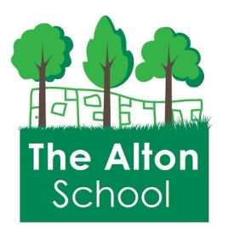
Autumn One: Holiday Homework

