Maths  Find the population of at least 10 cities from around the world. Order them from the largest to smallest.  https://www.worldometers.info/world-population/ | DT: London and Beyond  Create a 3D model of something from your learning this half term (e.g. a planet, a pyramid). | Science:  During the winter some animals hibernate. Research what this means and how they are able to do it. Create a fact file on this animal.
Geography: London and Beyond  Choose any city from around the world (for example Manaus, Cape Town) you might want to choose one you have been learning about. Compare this city to London. What is similar? What is different? | English  Write a poem inspired by this half term’s learning. For example you might want to do an acrostic poem on planets. | Computing: esafety  This half term we had anti-bullying week. Create a poster on how to stay safe on the internet.
Rights Respecting  We have achieved our rights respecting gold award this term! Congratulations! Plan a way that we can celebrate our achievement ready to share with the School Council. | Art:  It’s getting cold outside! Create a winter inspired piece of art work. Can you do it using only 3 colours? Think carefully about the colours you have chosen. | Visit: The Natural History Museum  The Natural History Museum has free entry all year round and is great to visit during the winter. Why don’t you take your parents there this holiday and show them what you know!
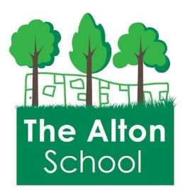
Autumn Two: Holiday Homework

