In the boxes below you will find many **adjectives** you can use to describe the different animals.

Can you also come up with suggestions of your own for describing the many animals?

Describing animals

**S P E E D**

quick, fast, slow, swift, speeding, rushing, hasty, bustling, rapid, snappy, brief, springy

**C O L O U R**

pink, red, orange, black, yellowish, blue, dark, green, purple, white, gray, brown

**S H A P E**

round, square, straight, triangular, oval, sleek, blobby, flat, elliptical, crooked, wavy

**S I Z E**

heavy, light, big, small, little, tiny, tall, short, fat, thin, skeletal, giant, underweight, wide

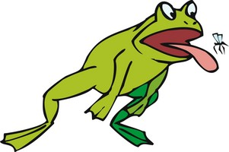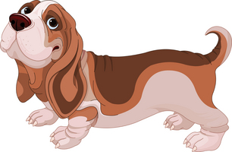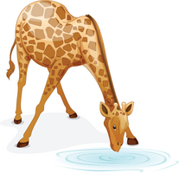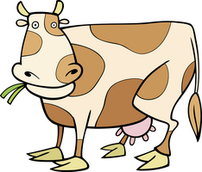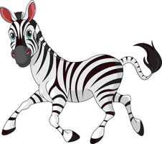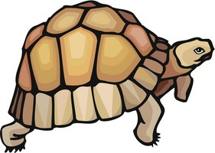

**1**

1. ____________________

2. ____________________

3. ____________________

4. ____________________

5. ____________________

**2**

1. ____________________

2. ____________________

3. ____________________

4. ____________________

5. ____________________

**3**

1. ____________________

2. ____________________

3. ____________________

4. ____________________

5. ____________________

**4**

1. ____________________

2. ____________________

3. ____________________

4. ____________________

5. ____________________

**8**

1. ____________________

2. ____________________

3. ____________________

4. ____________________

5. ____________________

**7**

1. ____________________

2. ____________________

3. ____________________

4. ____________________

5. ____________________

**6**

1. ____________________

2. ____________________

3. ____________________

4. ____________________

5. ____________________

**5**

1. ____________________

2. ____________________

3. ____________________

4. ____________________

5. ____________________

**12**

1. ____________________

2. ____________________

3. ____________________

4. ____________________

5. ____________________

**11**

1. ____________________

2. ____________________

3. ____________________

4. ____________________

5. ____________________

**10**

1. ____________________

2. ____________________

3. ____________________

4. ____________________

5. ____________________

**9**

1. ____________________

2. ____________________

3. ____________________

4. ____________________

5. ____________________