**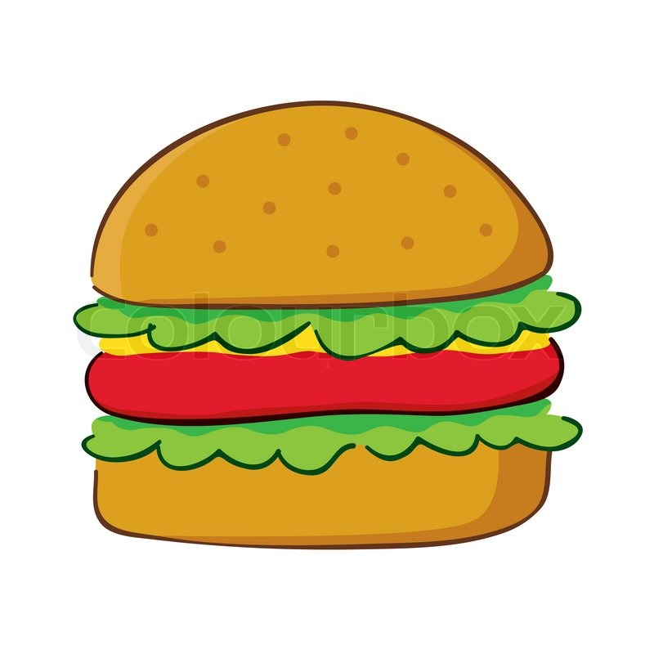****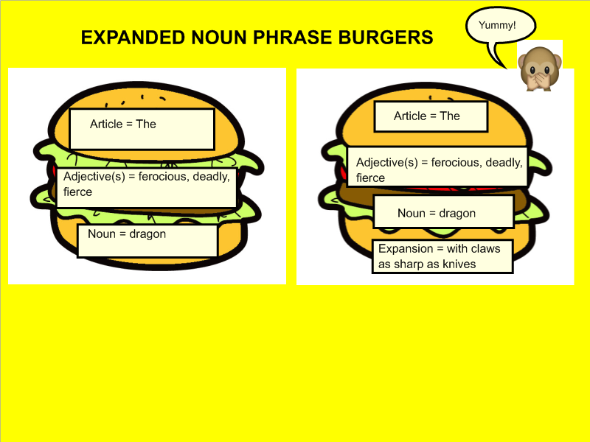Create delicious expanded noun phrase burgers with lots of fillings (adjectives) to describe a mythical creature!**

Expansion =

Noun =

Adjective(s)=

Article =

Expansion =

Noun =

Adjective(s)=

Article =

Adjective(s)=

Noun =

Expansion =

Article =

Adjective(s)=

Noun =

Article =

Noun =

Adjective(s)=

Article =

Article =

Adjective(s)=

Noun =



Word bank

gigantic enormous terrifying blood-thirsty fire-breathing pointy teeth

aggressive deadly vicious fierce beast strong scaly

colossal ferocious muscly ugly grim horrifying hideous

sly sharp sneaky unpredictable wild vulgar