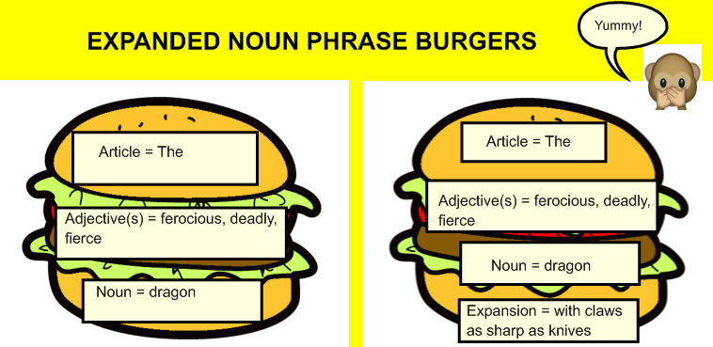
Create delicious expanded noun phrase burgers with lots of fillings (adjectives) to describe a mythical creature!
Expansion = with
Noun = chimera
Adjective(s)=
Article = The
Expansion = with
Noun = cyclops
Adjective(s)=
Article = The
Adjective(s)=
Noun = sea-dragon
Expansion = with
Article = The
Adjective(s)=
Noun = phoenix
Article = The
Noun = werewolf
Adjective(s)=
Article = The
Article = The
Adjective(s)=
Noun = dragon

Word bank
gigantic enormous terrifying blood-thirsty fire-breathing pointy teeth
aggressive deadly vicious fierce beast strong scaly
colossal ferocious muscly ugly grim horrifying hideous
sly sharp sneaky unpredictable wild vulgar

