Look at the picture of the Pegasus. Complete the complex sentence using a main and subordinating clause.
E.g Pegasus cannot breathe under water because he is not a sea animal.

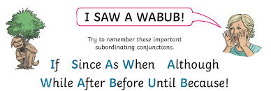
Main clause (makes sense by itself)
Subordinating clause (cannot make sense by itself, uses a subordinating conjunction – I SAW A WABUB)

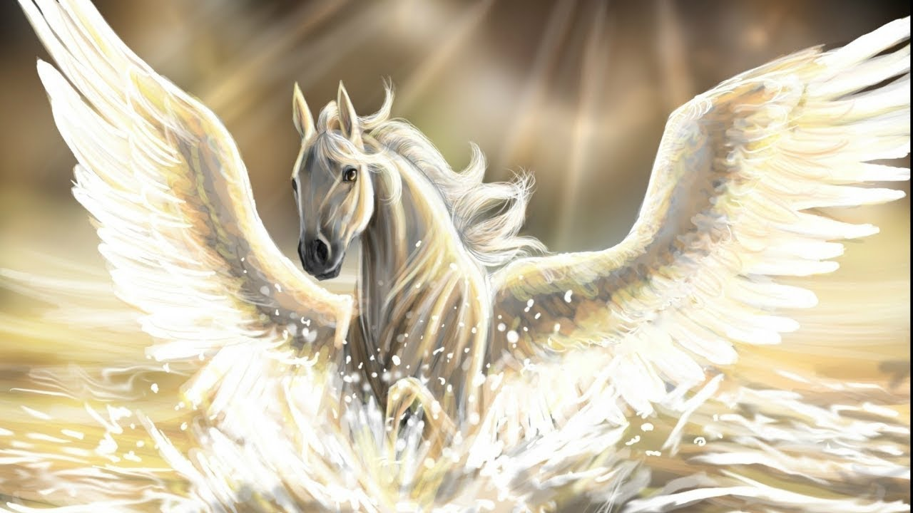

Describe why Pegasus has wings:
Pegasus has wings because __________________________________________
Finish explaining what the Pegasus was doing:
Pegasus fell into the deep blue sea and tried to swim although ______________________
Finish explaining when Pegasus finished the action:
Pegasus flew to the ends of the earth before __________________________________
Challenge – Create your own sentence using a main and subordinating clause
_______________________________________________________________

