10th December 2019
Maths
- Write each of the following in meter and centimetres, using the part, part whole.
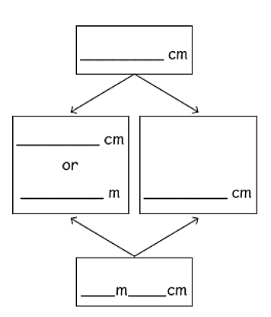
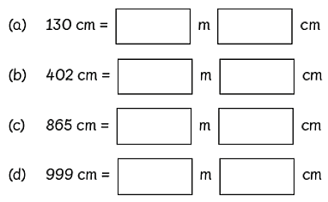
Part, Part whole

- Look at the map and answer the questions.
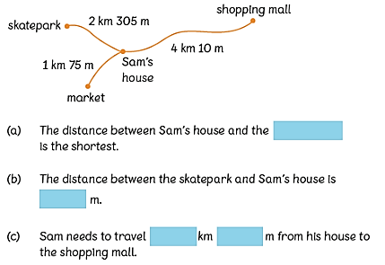

- To measure how tall your family are.
- Who is the tallest?
- Who is the shortest?
- Place them from shortest to tallest.

Shortest Tallest.

